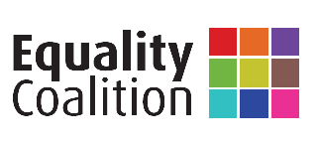

Background Information
And
Recent Achievements
2014/2015

Background to the Equality Coalition

The Equality Coalition is a broad alliance of non-governmental organisations whose members cover all the categories listed in Section 75 of the Northern Ireland Act 1998 (‘s75’), as well as other equality strands. It was founded in 1996 by community and voluntary sector organisations and trade unions. It was instrumental in putting equality at the forefront of the agenda at that time, specifically in relation to PAFT, the Good Friday/Belfast Agreement, and ultimately the public sector duty in s75. The Equality Coalition now has over 80 members, many of which are umbrella organisations. It is co-convened by CAJ and UNISON.

The Equality Coalition continues to provide a forum for unity between all sectors when campaigning for equality, while allowing for the diversity of its members’ work and views. By facilitating a strong message from diverse equality groups, mutual support between members, and consideration of the multiple identity aspects of equality work, it helps to ensure maximum impacts in a resource efficient manner. This approach is particularly important in the current environment, where organisations’ resources are challenged and cuts to public services are impacting disproportionately on the most disadvantaged groups in our society.

There are two key tenets to the work of the Coalition: the first is information sharing and capacity building; the second is lobbying and advocacy. Its aims and objectives can be summarised as:

- To ensure the equality duty is put into practice.
- To raise the public profile of the equality agenda in Northern Ireland.
- To facilitate information sharing.
- Strategic planning to effect change for critical equality issues.

The Equality Coalition has bi-monthly meetings, at which members can exchange information and discuss current equality issues. In addition, the Equality Coalition compiles and circulates information on public consultations, members’ and other events, and equality news. It also facilitates quarterly high level meetings with the Equality Commission and the OFMDFM Equality Unit. The Equality Coalition hosts several events to facilitate engagement with public authorities, build capacity and allow for networking between members. It is also available to provide advice and support on equality matters.

Staffing

The Equality Coalition and its staff members have always been run from within CAJ, with joint direction from UNISON. There has been and remains no other collective voice on equality for the sector in Northern Ireland. There remains no other overarching consistent ‘critical friend’ of the equality oversight bodies, public authorities and local government. CAJ employs a specialist human rights post in the Equalities Coordinator who both engages on CAJ-led equalities initiatives but also runs the Equality Coalition. Equalities actions requiring a formal legal personality, such as litigating on the absence of an anti-poverty strategy or issuing equality schemes complaints, can and are easily taken forward by CAJ or other member groups.

Recent Achievements

Back in the beginning the Equality Coalition was instrumental in getting the ‘Section 75’ equality duty in the Belfast/Good Friday Agreement and on to the statute books. More recently the Equality Coalition and its members have been at the forefront of seeking to protect and effectively operationalise the equality duty. Some recent initiatives include:

- The Equality Coalition successfully campaigned to prevent the now-shelved proposals in the ‘Together: Building a United Community’ (T:BUC) community relations strategy being used to water down the equality duty;

- The Equality Coalition commissioned independent research and a roundtable on ‘Defining Good Relations in Law’. Following this ‘lay definitions’ have become less tenable and the Equality Commission has now proposed to define the term ‘good relations’ in a human rights compliant manner;

- The Equality Coalition also held a roundtable event and issued a paper on the subject of ‘Defining sectarianism in Law’ and successfully saw off an attempt to legislate for a very restricted definition of sectarianism in Northern Ireland;

- Successful intervention during the passage of the Local Government NI Act 2014 to promote an amendment building in equality duty and objective need considerations into the new ‘community planning’ functions of the new councils;

- Following intense engagement by the Equality Coalition on effective use of enforcement powers in relation to the welfare reform bill, the Equality Commission agreed to a request from CAJ to launch a formal investigation into DSD for bypassing equality duties in developing strategic housing policy. This strategic intervention was shaped following evidence uncovered by PPR who are members of the Equality Coalition;

- Rather than simply voicing concerns when the equality duties are not given due weight the Equality Coalition has taken an approach of ensuring breaches are responded to by formal complaints by affected persons. The Equality Coalition held an Equality schemes ‘complaints’ seminar and has held training with UNISON shop-stewards, and assisted a range of groups in taking complaints. CAJ themselves have intervened on matters such as cuts to the Police Ombudsman’s office or the discontinuation of a childcare scheme for staff at the NI Assembly, where the duties under equality schemes were not properly actioned. Our encouragement of others to make complaints has also led to, for example, hundreds of PSNI officers issuing complaints against the Department of Justice in relation to changes to their pension arrangements, and smaller numbers of directly affected persons doing the same on other policy issues, usually linked to austerity;

- The Equality Coalition is hosted a major international conference entitled Austerity and Inequality: ‘A threat to peace?’ This was addressed, among others by the head of the Stormont-House mandated OECD mission to NI, a member of the UN ICESCR Committee, the heads of the Equality and Human Rights Commissions and a range of civil society organisations who are members of the Equality Coalition, including PPR, the Human Rights Consortium, the Rural Community Network and ICTU. It also featured a presentation from the barrister instructed in the PILS-funded CAJ judicial review of the anti-poverty strategy, Gordon Anthony BL;
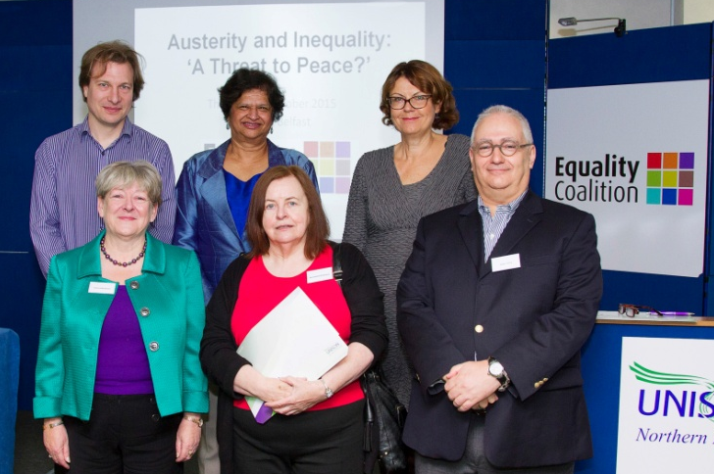

Daniel Holder CAJ, Virginia Bras Gomes, Susan McKay
Patricia McKeown UNISON, Bernadette McAliskey STEP and Adam Ostry OECD at Austerity and Inequality Conference Oct 2015

- The Equality Coalition held a seminar in April 2015 to highlight the equalities impacts of the Stormont House Agreement, and has now partnered with academic researchers who, on funding from the Irish Government anti-sectarianism fund, are producing a research report collaboratively with the Equality Coalitions member-groups as a supplementary source of information to official statistics;

- The Equality Coalition Co-Conveners engaged, alongside the heads of ICTU and NIPSA with the OECD mission to NI;

- The Equality Coalition has taken an approach to keeping member groups together on politically contentious issues without ever diluting equalities principles. We meet senior OFMDFM officials and Ministers, as well as the Equality Commission as a Coalition. Decisions are taken by consensus at meetings and this also helps member groups engage in equality matters beyond their organisations normal remit. For example it was the Equality Coalition who responded collectively to the DUP consultation on a ‘conscience clause’ designed to legalise forms of hitherto unlawful discrimination against persons on grounds of sexual orientation when done for reasons of ‘religious conscience’. Our response combined the collective strength of the Equality Coalition membership, with the human rights expertise of CAJ to be able to critique the positions in the consultation paper against international standards;

We have taken an approach of maximising the impact of interventions by the Equality Coalition and its members in relation to policy development and implementation. In practice this has meant that in recent times we have moved away from the approach of large scale responses to formal policy consultation documents to much more of a tailored activist approach.

The strength of collective action is not to be doing countless submissions, but rather to take an outcomes focused approach at the big contentious policy questions of the day, using a range of methodologies including expert analysis of equality policy and practice, mobilisation of civil society organisations and shaping power through high level lobbying and litigation.

January 2016

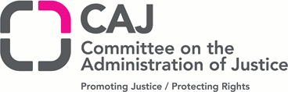

The Equality Coalition have all publications mentioned and more including equality scheme complaint templates and a guide on the proper application of section 75 when policy making on the website. Monthly equality updates are also available online including all information on upcoming events.

If you would like to receive any further information on the Equality Coalition, to become a member or to receive updates on our work please contact us on the details overleaf.

Equality Coalition
c/o CAJ
1st Floor, Community House
Citylink Business Park
6A Albert Street
Belfast
BT12 4HQ

Tele: 02890992548
Text phone: 07703 486949
Web www.equalitycoalition.net
Email: equalitycoalition@caj.org.uk
Follow us on Twitter @EqualityCoal

